Citator Symbols

Statutes

Westlaw
Indicates the statute has been amended, repealed, superseded, held unconstitutional, or preempted
Indicates the statute has proposed legislation or has been renumbered, a prior version received negative treatment, or the statute’s validity has been called into doubt

Lexis
 | Indicates the statute has been treated positively by a case
 | Indicates the statute has been deemed unconstitutional, void, or invalid
 | Indicates the statute’s been superseded by another authority
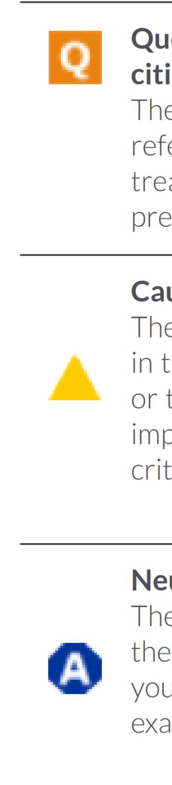 | Indicates the statute has been criticized or distinguished by a case
 | Indicates the statute has been analyzed, neither negatively nor positively, by a case
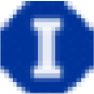 | Indicates the statute has been cited to
Cases

Westlaw
 | Indicates the case is no longer good law for at least one of the points it contains
 | Indicates the case has some negative history, but has not been reversed or overruled
 | Indicates the case has been appealed to the U.S. Court of Appeals or the U.S. Supreme Court
 | Indicates the case may have been implicitly undermined due to its reliance on another case that has been overruled

Lexis
 | Indicates the case has been treated positively by a case
 | Indicates questions about the continuing validity or precedential value of the case because of intervening circumstances, including judicial or legislative overruling
 | Indicates at least one part of the case has been overruled, abrogated, or superseded
 | Indicates the case has been criticized or distinguished by a case
 | Indicates the case has been analyzed, neither negatively nor positively, by a case
 | Indicates the case has been cited to

